VIRTUAL DISCOUNT -LIMITED TIME OFFER - XXXVI WORLD CONGRESS OF SPORTS MEDICINE, FIMS2020, DIVANI CARAVEL HOTEL, ATHENS, SEPTEMBER 23rd - 26th 2021
Απάντηση-Προς: info@fims2020.com
View in browser



LIMITED TIME OFFER
FIMS GOES VIRTUAL

Use the following code for 20% disccount to all
virtual registration costs

Discount Code
VIRTUAL

Code Valid Until 17/9

To register click here

For further registration or reservation issues please contact registration@fims2020.com or reservations@fims2020.com
For more travel options please contact travel@globalevents.gr
For more information please visit the official website at fims2020.com
Sincerely,

Chryssa Grepsiou
Organizing Secretariat
36th World Congress of Sports Medicine

For Scientific Matters:
info@fims2020.com
For Sponsorship:
sponsors@fims2020.com
www.fims2020.com
For Registration:
registrations@fims2020.com
For Accommodation:
reservations@fims2020.com

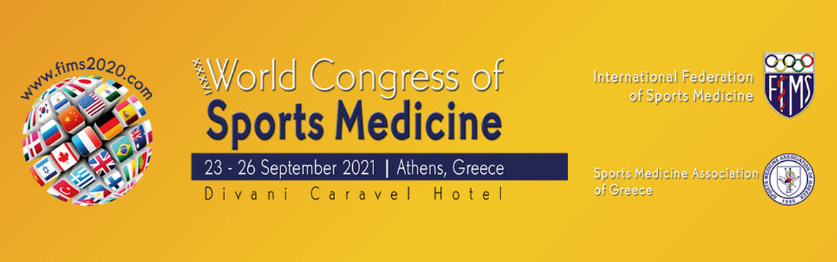

  GLOBAL EVENTS
  www.globalevents.gr
  
  50Α Stadiou Str., 55534, Pilea, Thessaloniki, Greece
  Tel.:(+30) 2310 247743 | 2310 247745
  Fax :(+30) 2310247746
  E-mail: info@globalevents.gr
  2 Valestra Str. & 168 A. Syngrou Av., 17671 Kallithea, Athens, Greece
  Tel.:(+30) 210 3250260 | 211 1825814
  E-mail: athens@globalevents.gr
  
  
  
  
  

This email was sent to info@ispellas.gr
You received this email because you are registered with Global Events

Unsubscribe here

© 2021 Global Events

